Day 14 - 04th july 2025

Task 1:

Create  a custom node , add elements to it and traverse it..

Task 1 :

// Node class  
class Node {  
 int data;  
 Node next;  
  
 Node(int data) {  
 this.data = data;  
 this.next = null;  
 }  
}  
  
// LinkedList class  
public class LinkedList {  
 Node head;  
  
 // Method to add a node at the end  
 public void add(int data) {  
 Node newNode = new Node(data);  
  
 if (head == null) {  
 head = newNode;  
 } else {  
 Node current = head;  
 while (current.next != null) {  
 current = current.next;  
 }  
 current.next = newNode;  
 }  
 }  
  
 // Method to traverse and display the list  
 public void display() {  
 Node current = head;  
  
 if (current == null) {  
 System.*out*.println("The list is empty.");  
 return;  
 }  
  
 System.*out*.print("Linked List Elements: ");  
 while (current != null) {  
 System.*out*.print(current.data + " ");  
 current = current.next;  
 }  
 System.*out*.println();  
 }  
  
 // Main method  
 public static void main(String[] args) {  
 LinkedList list = new LinkedList();  
  
 // Adding 4 elements  
 list.add(10);  
 list.add(20);  
 list.add(30);  
 list.add(40);  
  
 // Displaying elements  
 list.display();  
 }  
}

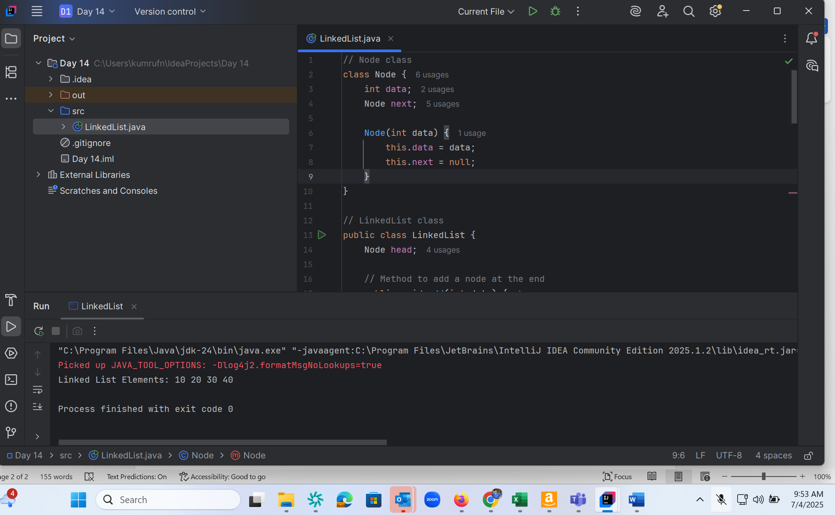

Task 2 :

The traversal starts at the head node. Then it moves to the next node using the next pointer. This continues until it reaches the last node, where next == null. You typically traverse a list to: Display the elements. Search for a value. Modify or delete elements. Count nodes

Task 3 :

Create a Circular Linked list using Task 1 Singly linked list/ doubly linked list.

// Node class  
class Node {  
 int data;  
 Node next;  
  
 Node(int data) {  
 this.data = data;  
 this.next = null;  
 }  
}  
  
// CircularLinkedList class  
public class CircularLinkedList {  
 Node head = null;  
 Node tail = null;  
  
 // Method to add a node to the circular list  
 public void add(int data) {  
 Node newNode = new Node(data);  
  
 if (head == null) {  
 head = newNode;  
 tail = newNode;  
 newNode.next = head; // Circular link  
 } else {  
 tail.next = newNode; // Add new node after tail  
 tail = newNode; // Move tail to new node  
 tail.next = head; // Maintain circular link  
 }  
 }  
  
 // Method to traverse and display the circular list  
 public void display() {  
 Node current = head;  
  
 if (head == null) {  
 System.*out*.println("The list is empty.");  
 return;  
 }  
  
 System.*out*.print("Circular Linked List Elements: ");  
 do {  
 System.*out*.print(current.data + " ");  
 current = current.next;  
 } while (current != head); // Stop when we reach the head again  
  
 System.*out*.println();  
 }  
  
 // Main method  
 public static void main(String[] args) {  
 CircularLinkedList list = new CircularLinkedList();  
  
 // Adding 4 elements  
 list.add(10);  
 list.add(20);  
 list.add(30);  
 list.add(40);  
  
 // Displaying the list  
 list.display();  
 }  
}

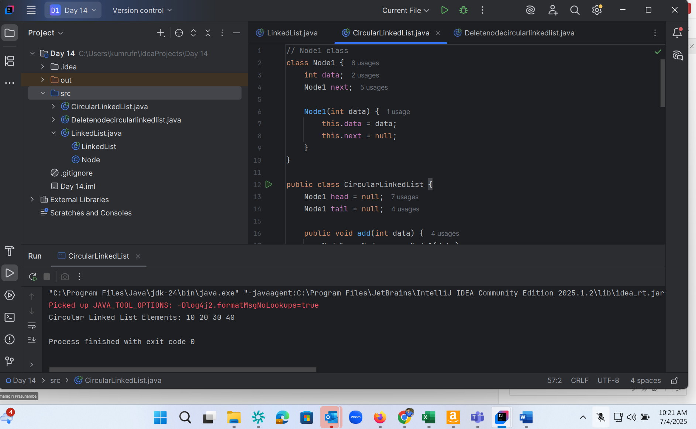

Task 4 :

Delete a node in the circular linked list

// Node2 class  
class Node2 {  
 int data;  
 Node2 next;  
  
 Node2(int data) {  
 this.data = data;  
 }  
}  
  
// Circular Linked List class  
public class Deletenodecircularlinkedlist {  
 Node2 head = null;  
 Node2 tail = null;  
  
 // Add node to circular linked list  
 public void add(int data) {  
 Node2 newNode = new Node2(data);  
  
 if (head == null) {  
 head = newNode;  
 tail = newNode;  
 tail.next = head;  
 } else {  
 tail.next = newNode;  
 tail = newNode;  
 tail.next = head;  
 }  
 }  
  
 // Delete node by value  
 public void delete(int value) {  
 if (head == null) {  
 System.*out*.println("List is empty.");  
 return;  
 }  
  
 Node2 current = head;  
 Node2 prev = tail;  
  
 // Special case: deleting head node  
 do {  
 if (current.data == value) {  
 if (current == head) {  
 if (head == tail) {  
 head = tail = null; // Only one node  
 } else {  
 head = head.next;  
 tail.next = head;  
 }  
 } else {  
 prev.next = current.next;  
 if (current == tail) {  
 tail = prev;  
 }  
 }  
 System.*out*.println("Deleted node with value: " + value);  
 return;  
 }  
 prev = current;  
 current = current.next;  
 } while (current != head);  
  
 System.*out*.println("Value " + value + " not found in the list.");  
 }  
  
 // Display the list  
 public void display() {  
 if (head == null) {  
 System.*out*.println("The list is empty.");  
 return;  
 }  
  
 Node2 current = head;  
 System.*out*.print("Circular Linked List Elements: ");  
 do {  
 System.*out*.print(current.data + " ");  
 current = current.next;  
 } while (current != head);  
 System.*out*.println();  
 }  
  
 // Main method  
 public static void main(String[] args) {  
 Deletenodecircularlinkedlist list = new Deletenodecircularlinkedlist();  
  
 // Adding elements  
 list.add(10);  
 list.add(20);  
 list.add(30);  
 list.add(40);  
  
 System.*out*.println("Original list:");  
 list.display();  
  
 // Deleting a node  
 list.delete(20); // Delete middle  
 list.display();  
 // Try to delete from empty list  
 }  
}

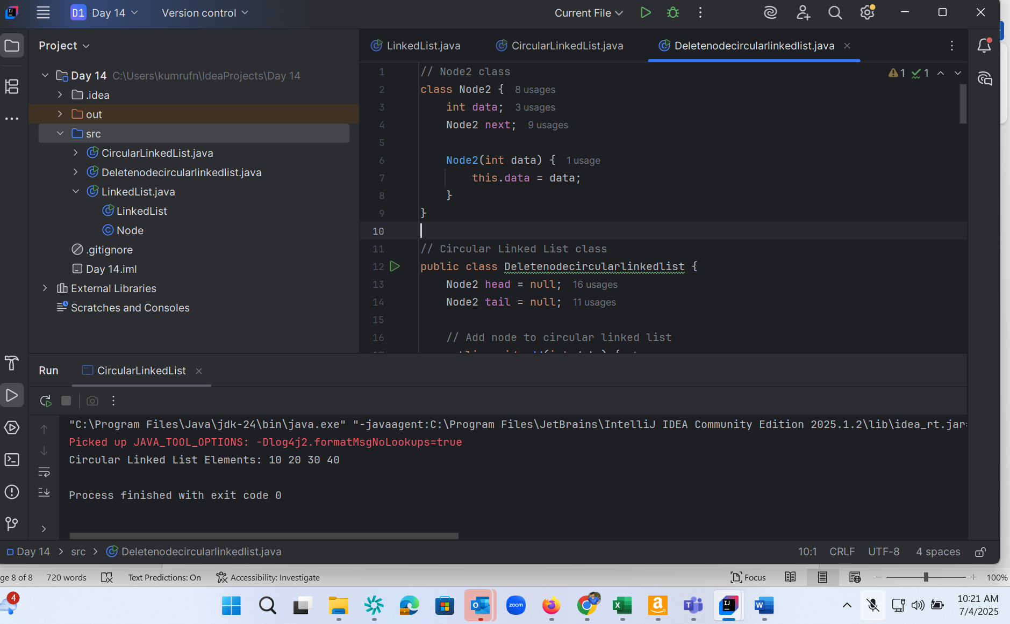

Task 5 :

import java.util.Stack;  
  
public class StackExample {  
 public static void main(String[] args) {  
 // Create a stack of integers  
 Stack<Integer> stack = new Stack<>();  
  
 // Push elements onto the stack  
 stack.push(10);  
 stack.push(20);  
 stack.push(30);  
  
 // Display the stack  
 System.*out*.println("Stack: " + stack);  
  
 // Pop the top element  
 int poppedElement = stack.pop();  
  
 // Print the popped element  
 System.*out*.println("Popped element: " + poppedElement);  
  
 // Display the stack after pop  
 System.*out*.println("Stack after pop: " + stack);  
 }  
}

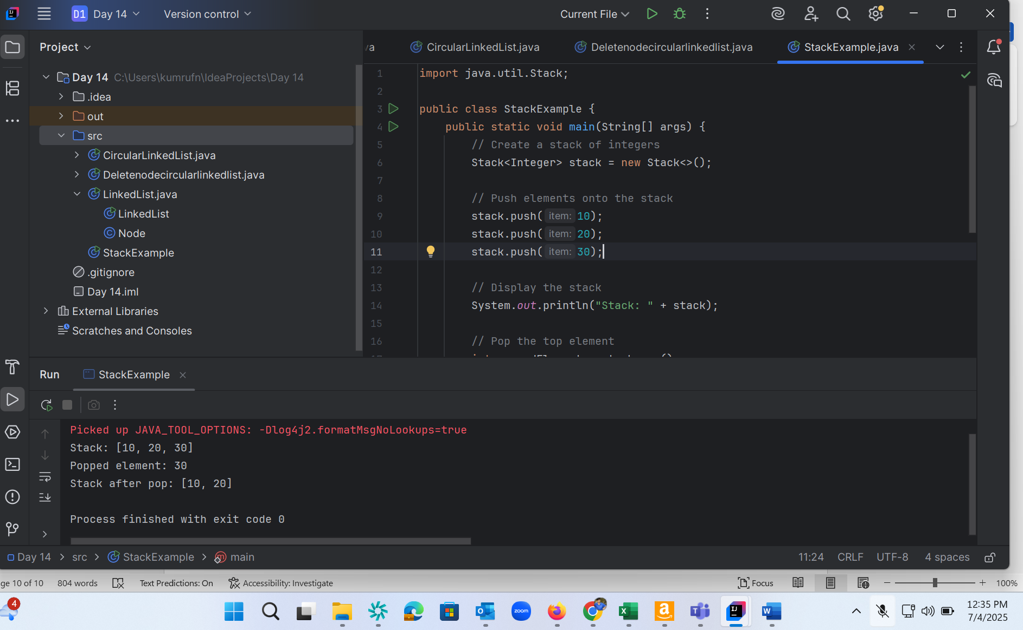

Task 6, 7, 8

import java.util.Stack;  
  
public class StackExample1 {  
 public static void main(String[] args) {  
 // Create a stack of integers  
 Stack<Integer> stack = new Stack<>();  
  
 // Push elements onto the stack  
 stack.push(10);  
 stack.push(20);  
 stack.push(30);  
 stack.push(40);  
  
 // Display the stack  
 System.*out*.println("Stack: " + stack);  
  
 // Pop the top element  
 int poppedElement = stack.pop();  
 int peekElement = stack.peek(); // returns an object from the top of the stack  
 int position = stack.search(20); //returns the position of the element from the top of the stack  
 boolean result = stack.empty(); //whether a stack is empty or not  
  
 // Print the popped element  
 System.*out*.println("Popped element: " + poppedElement);  
  
 // Display the stack after pop  
 System.*out*.println("Stack after pop: " + stack);  
 System.*out*.println("Stack after peek: " + peekElement);  
 System.*out*.println("Stack searching : " + position);  
 System.*out*.println("Stack searching : " + result);  
  
 }  
}

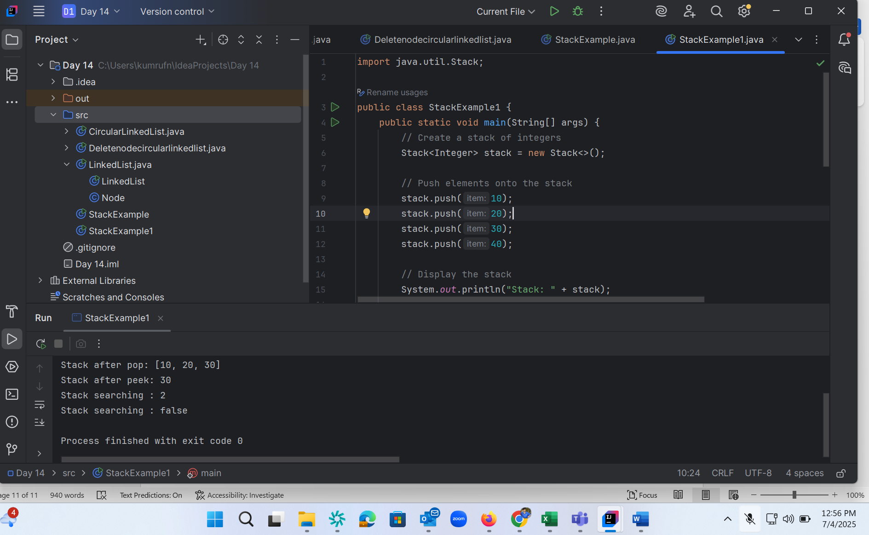

Task 7 :

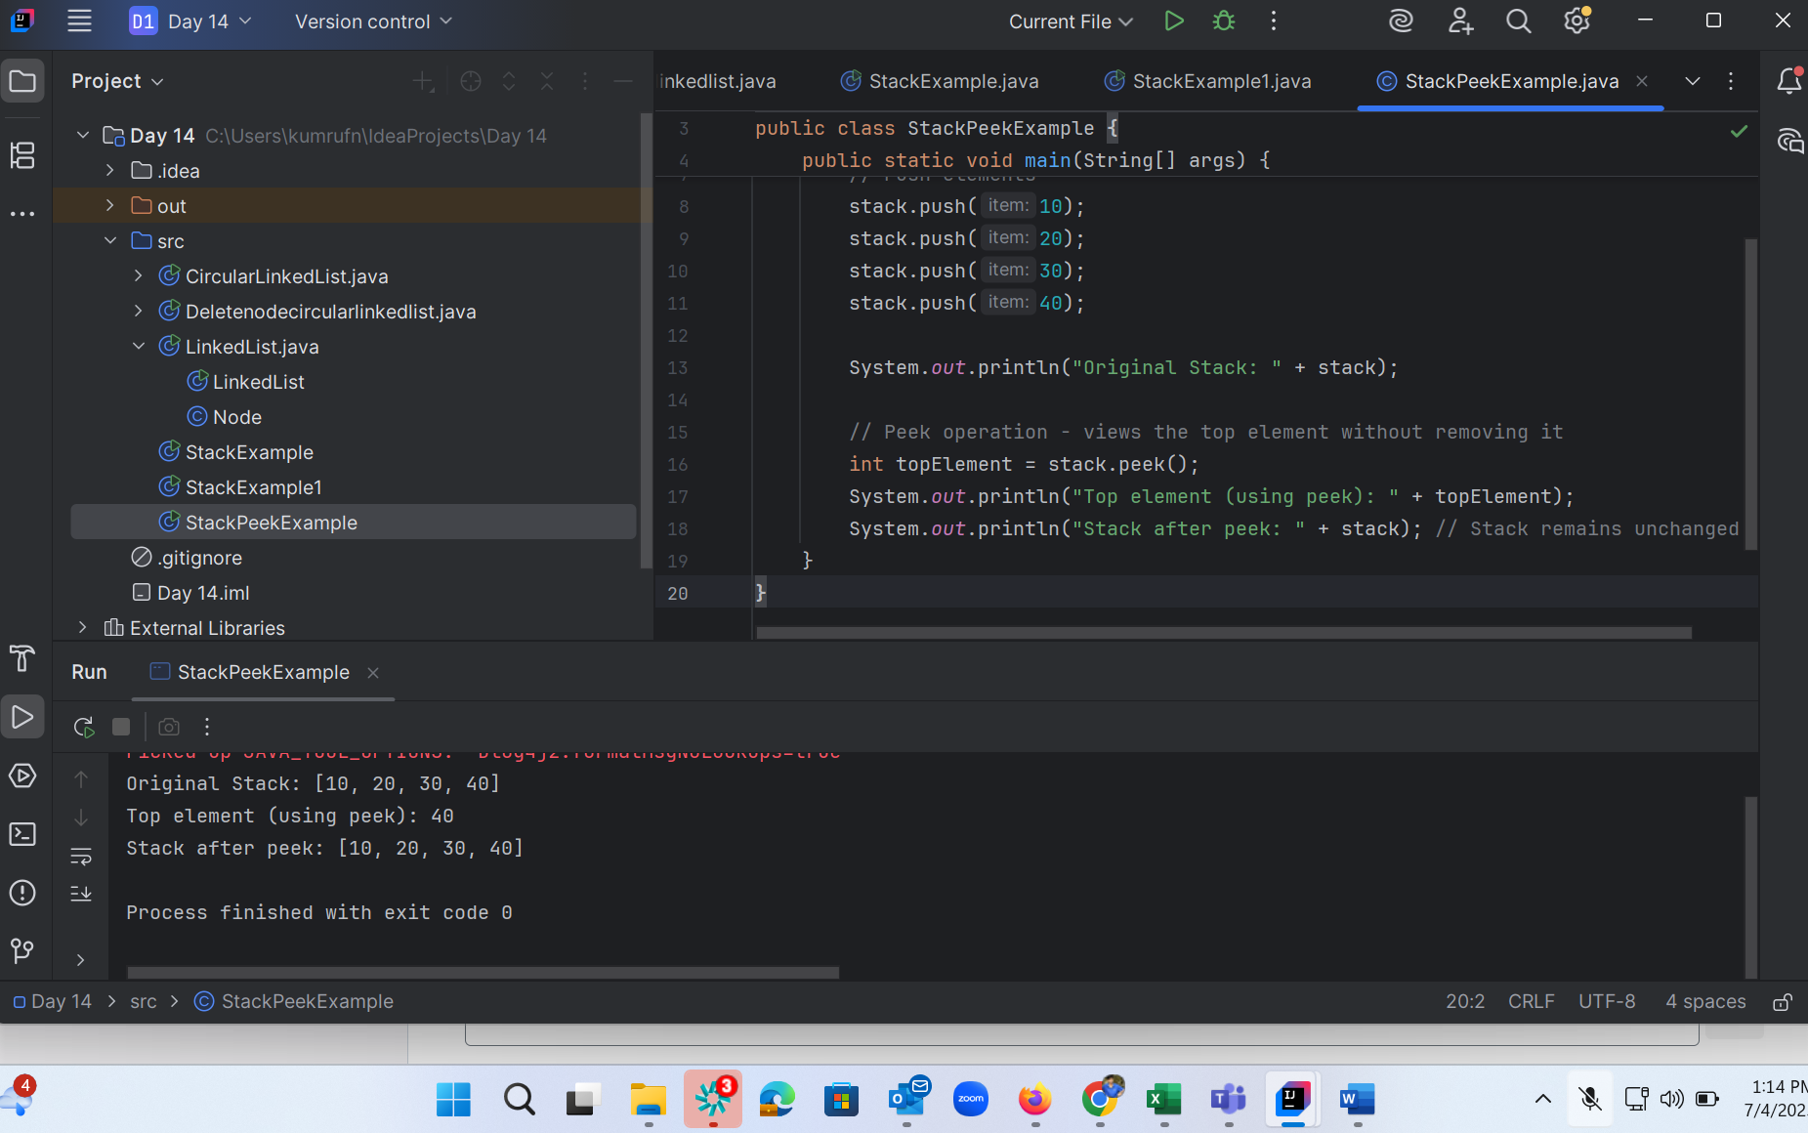

Task 9 :

push() - Adds an element to the top of the stack

pop() - Removes and returns the topmost element from the stack

peek() or top() - Returns the top element without removing it from the stack

isEmpty() - Returns true if the stack is empty, false otherwise

size() - Returns the number of elements currently in the stack

clear() - Removes all elements from the stack making it empty

isFull() - Returns true if the stack has reached its maximum capacity (for fixed-size implementations)

Task 10 :

public class CustomQueue {  
 private int[] queue;  
 private int front;  
 private int rear;  
 private int size;  
 private int capacity;  
  
 public CustomQueue(int capacity) {  
 this.capacity = capacity;  
 queue = new int[capacity];  
 front = 0;  
 rear = -1;  
 size = 0;  
 }  
  
 public boolean isEmpty() {  
 return size == 0;  
 }  
  
 public boolean isFull() {  
 return size == capacity;  
 }  
  
 public void enqueue(int data) {  
 if (isFull()) {  
 System.*out*.println("Queue is full. Cannot enqueue " + data);  
 return;  
 }  
 rear = (rear + 1) % capacity;  
 queue[rear] = data;  
 size++;  
 }  
  
 public int dequeue() {  
 if (isEmpty()) {  
 System.*out*.println("Queue is empty. Cannot dequeue.");  
 return -1;  
 }  
 int removed = queue[front];  
 front = (front + 1) % capacity;  
 size--;  
 return removed;  
 }  
  
 public int peek() {  
 if (isEmpty()) {  
 System.*out*.println("Queue is empty. Nothing to peek.");  
 return -1;  
 }  
 return queue[front];  
 }  
  
 public void display() {  
 if (isEmpty()) {  
 System.*out*.println("Queue is empty.");  
 return;  
 }  
  
 System.*out*.print("Queue elements: ");  
 for (int i = 0; i < size; i++) {  
 int index = (front + i) % capacity;  
 System.*out*.print(queue[index] + " ");  
 }  
 System.*out*.println();  
 }  
  
 // Main method to test the custom queue  
 public static void main(String[] args) {  
 CustomQueue q = new CustomQueue(5);  
  
 q.enqueue(10);  
 q.enqueue(20);  
 q.enqueue(30);  
 q.display(); // Output: 10 20 30  
  
 System.*out*.println("Peek: " + q.peek()); // Output: 10  
 System.*out*.println("Dequeued: " + q.dequeue()); // Output: 10  
  
 q.display(); // Output: 20 30  
 System.*out*.println("Is full? " + q.isFull()); // false  
  
 q.enqueue(40);  
 q.enqueue(50);  
 q.enqueue(60); // Fills the queue  
 q.display();  
  
 q.enqueue(70); // Should show full message  
 }  
}

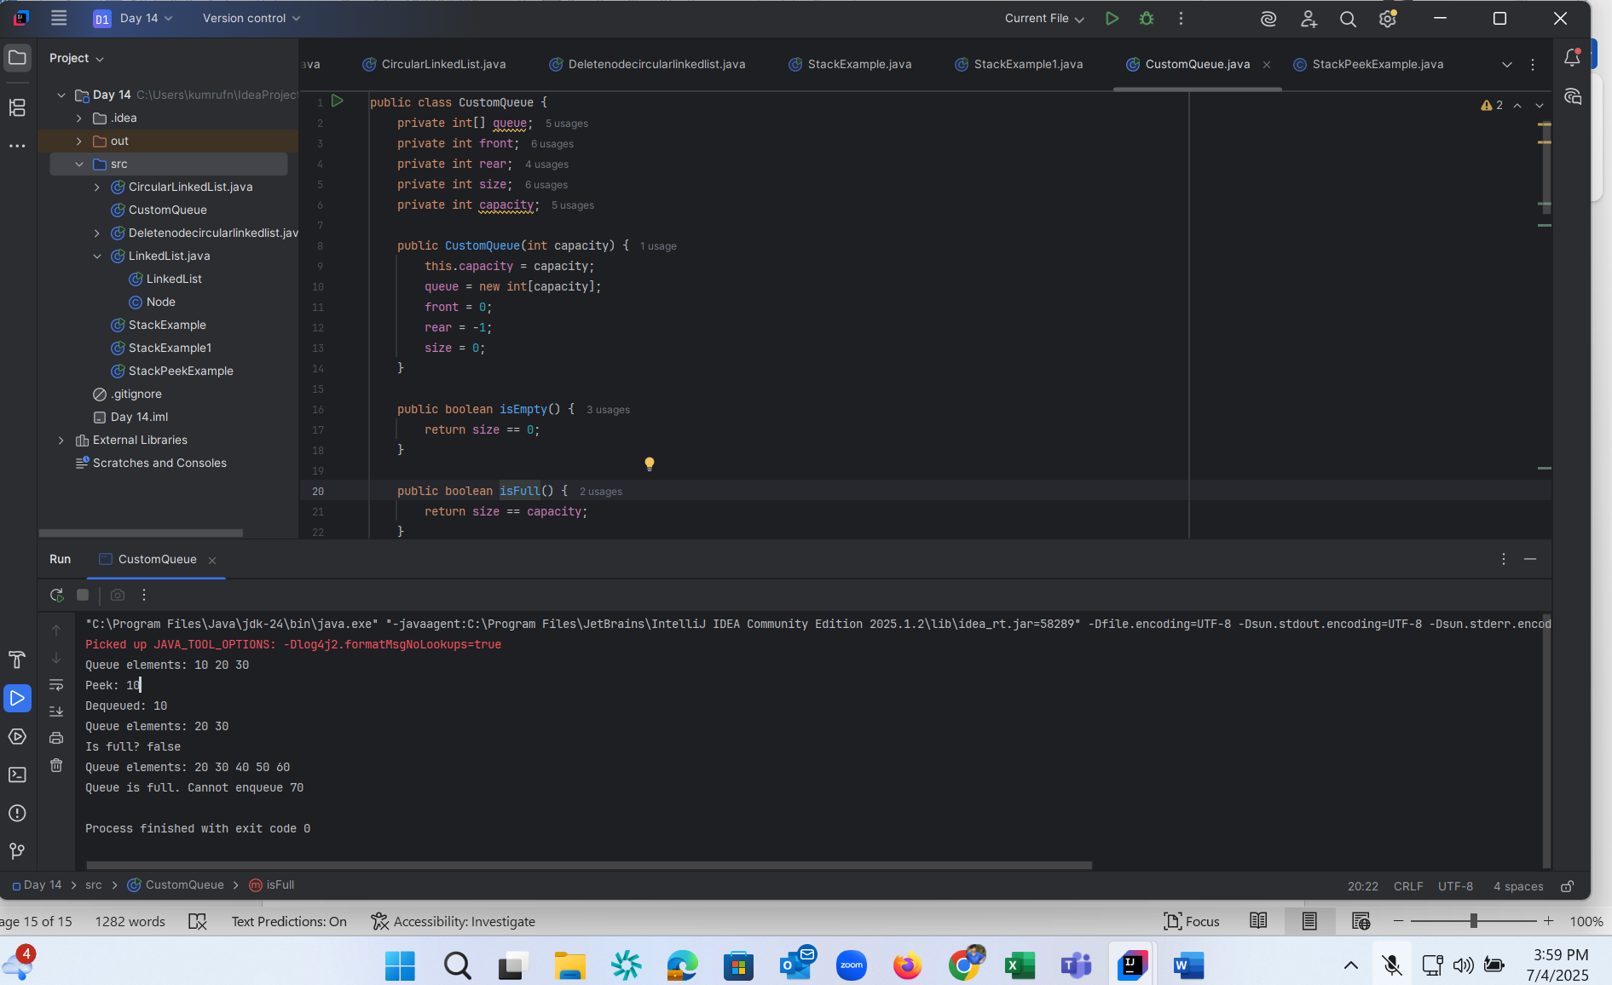

Home Tasks: Recursion: Wap to find the factorial of a number

public class hometask01 {

// Recursive method to find factorial

public static int factorial(int n) {

if (n == 0 || n == 1) {

return 1; // Base case: 0! = 1 and 1! = 1

} else {

return n \* factorial(n - 1); // Recursive call

}

}

public static void main(String[] args) {

int num = 5; // Change this to any number you want

int result = factorial(num);

System.out.println("Factorial of " + num + " is: " + result);

}

}

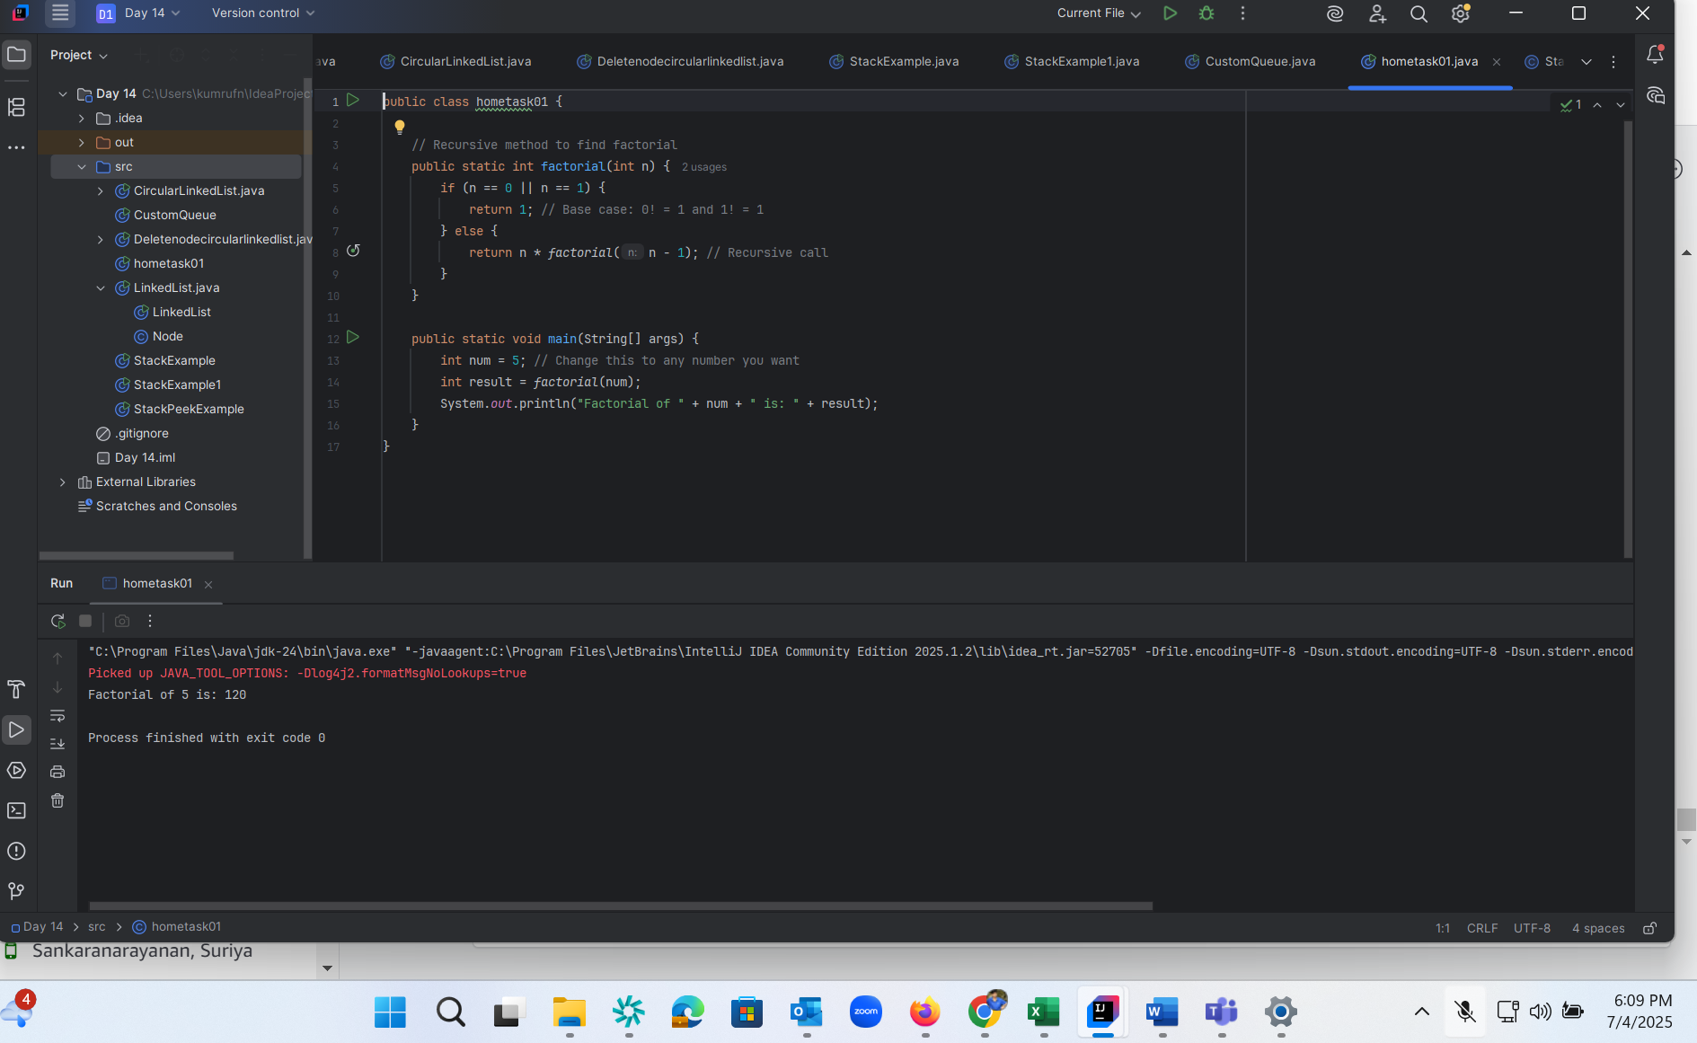

2.Wap to find the Fibonacci series of a number

public class hometask02 {  
  
 // Recursive method to find the nth Fibonacci number  
 public static int fibonacci(int n) {  
 if (n == 0) return 0; // Base case 1  
 if (n == 1) return 1; // Base case 2  
 return *fibonacci*(n - 1) + *fibonacci*(n - 2); // Recursive step  
 }  
  
 public static void main(String[] args) {  
 int terms = 10; // Change this to print more or fewer terms  
  
 System.*out*.println("Fibonacci series up to " + terms + " terms:");  
 for (int i = 0; i < terms; i++) {  
 System.*out*.print(*fibonacci*(i) + " ");  
 }  
 }  
}

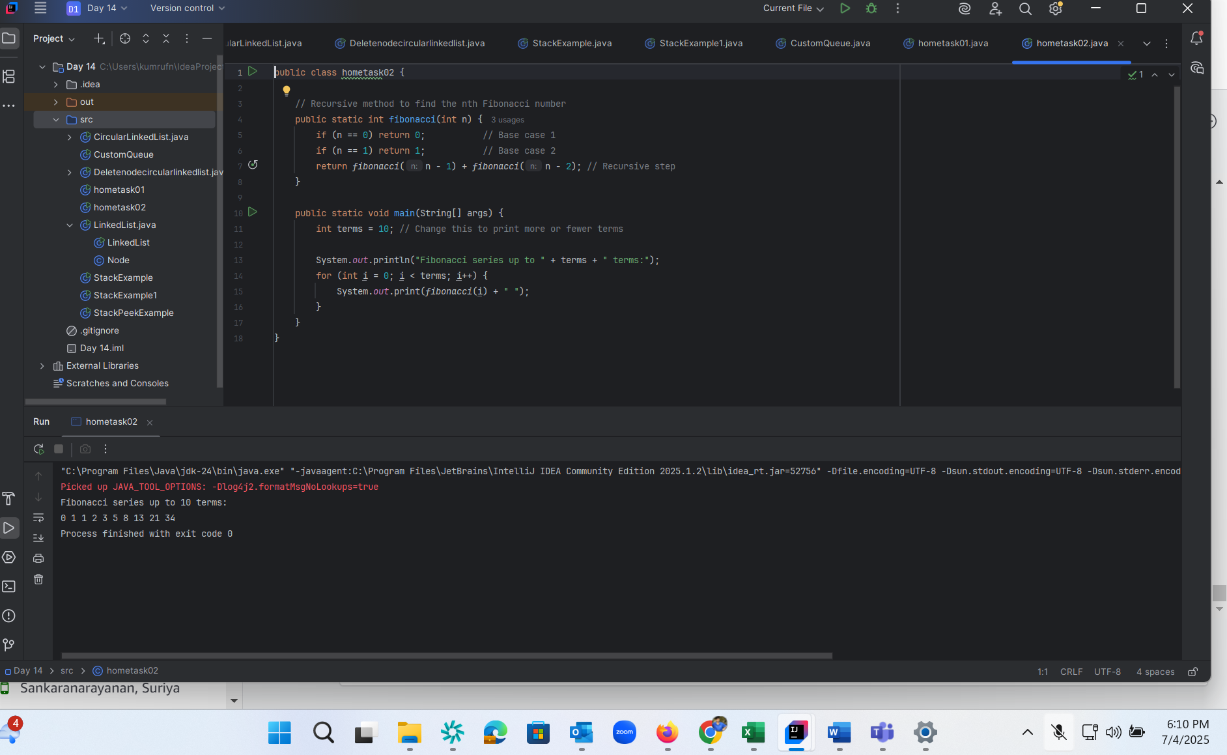

3. What is the difference between recursion and iteration Recursion is when a function calls itself to solve a smaller part of the problem, while iteration uses loops (for, while) to repeat steps until a condition is met.

Wap to reverse a string using recursion..

public class hometask03 {  
  
 // Recursive method to reverse a string  
 public static String reverse(String str) {  
 if (str.isEmpty()) {  
 return str; // Base case: empty string  
 }  
 return *reverse*(str.substring(1)) + str.charAt(0); // Recursive call  
 }  
  
 public static void main(String[] args) {  
 String input = "hello";  
 String reversed = *reverse*(input);  
 System.*out*.println("Original string: " + input);  
 System.*out*.println("Reversed string: " + reversed);  
 }  
}

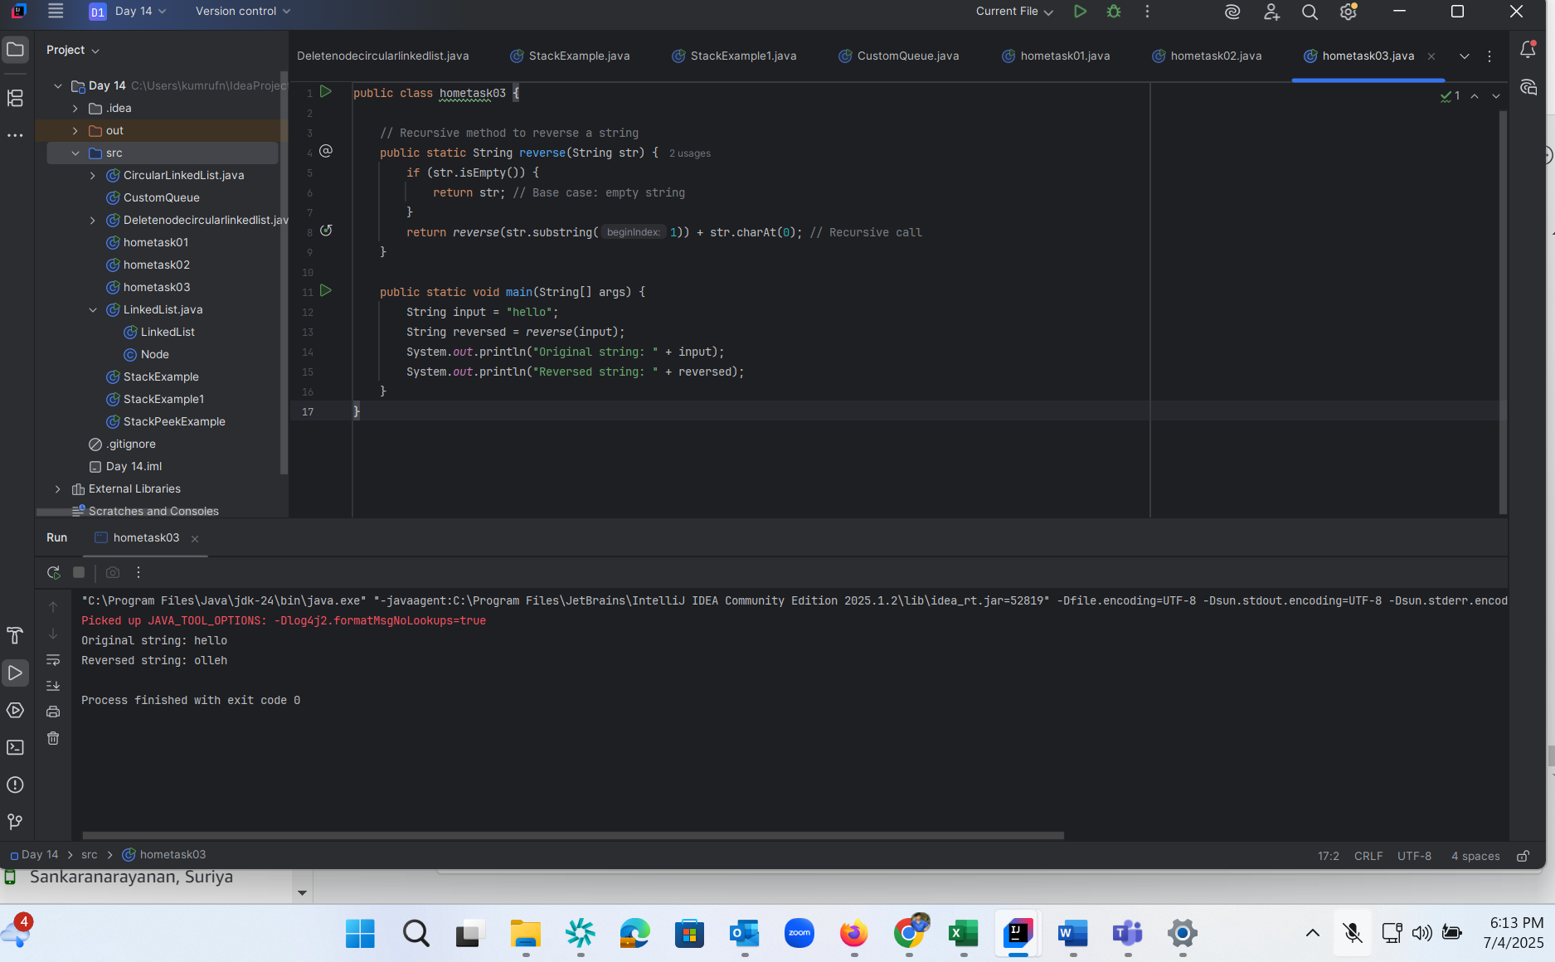

4. Write a recursive function to search for an element in an array

public class hometask04 {  
 // Recursive function to search for target in array  
 public static int recursiveSearch(int[] arr, int target, int index) {  
 // Base case: if index goes out of bounds  
 if (index >= arr.length) {  
 return -1; // not found  
 }  
  
 // If current element matches the target  
 if (arr[index] == target) {  
 return index;  
 }  
  
 // Recursive call: search in the rest of the array  
 return *recursiveSearch*(arr, target, index + 1);  
 }  
  
 public static void main(String[] args) {  
 int[] array = {4, 7, 2, 9, 1, 5};  
 int target = 9;  
  
 int result = *recursiveSearch*(array, target, 0);  
  
 if (result != -1) {  
 System.*out*.println("Element " + target + " found at index: " + result);  
 } else {  
 System.*out*.println("Element " + target + " not found in the array.");  
 }  
 }  
}

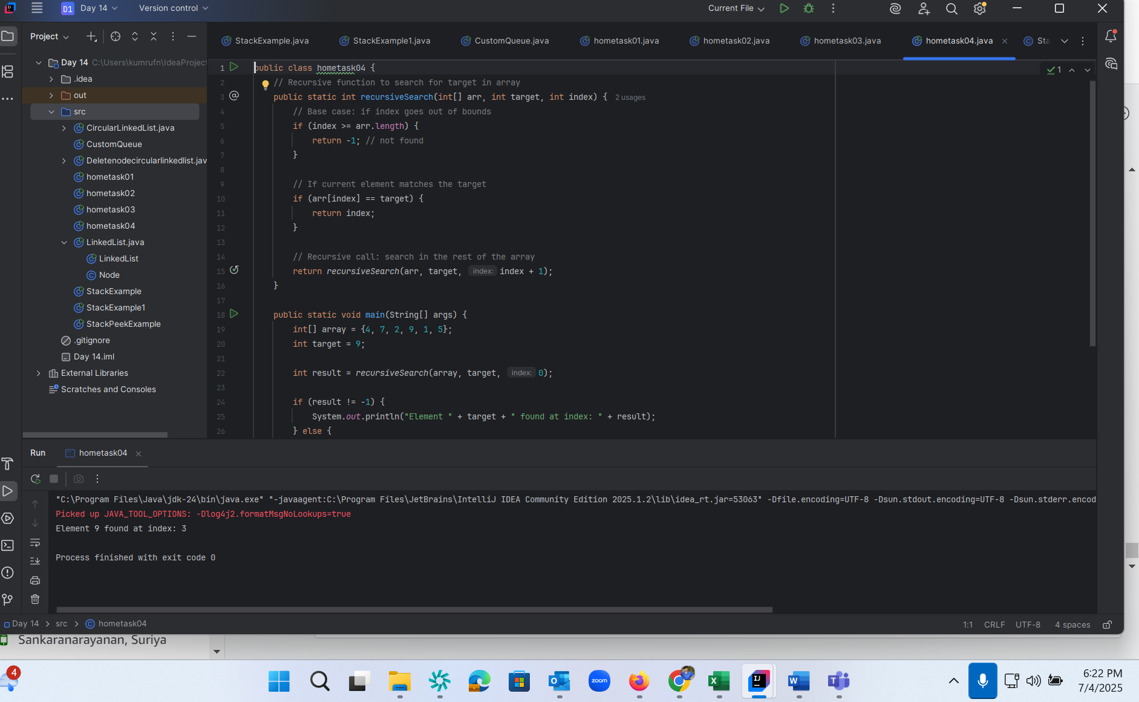

5. Write a recursive function to count the digits of a positive integer (do also for sum of digits)

public class hometask05 {  
 // Recursive function to count digits  
 public static int countDigits(int num) {  
 if (num == 0) {  
 return 0;  
 }  
 return 1 + *countDigits*(num / 10);  
 }  
  
 // Recursive function to sum digits  
 public static int sumDigits(int num) {  
 if (num == 0) {  
 return 0;  
 }  
 return (num % 10) + *sumDigits*(num / 10);  
 }  
  
 public static void main(String[] args) {  
 int number = 12345;  
  
 int digitCount = *countDigits*(number);  
 int digitSum = *sumDigits*(number);  
  
 System.*out*.println("Number: " + number);  
 System.*out*.println("Total digits: " + digitCount);  
 System.*out*.println("Sum of digits: " + digitSum);  
 }  
}

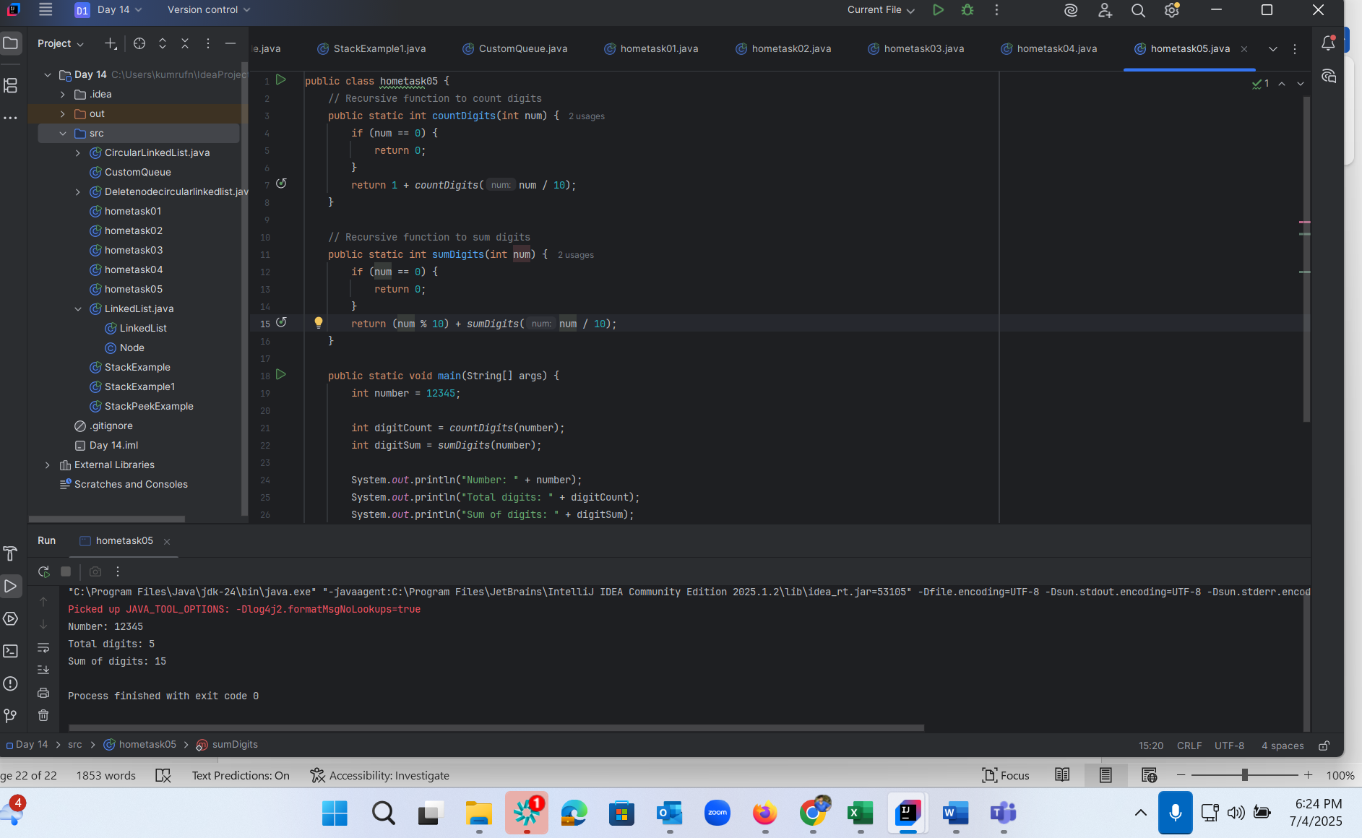

6. Write a recursive function to reverse a null-terminated string

public class hometask06 {  
 // Recursive function to reverse a string (simulating null-terminated behavior)  
 public static void reverse(char[] str, int index) {  
 if (str[index] == '\0') {  
 return; // Base case: reached null terminator  
 }  
 *reverse*(str, index + 1); // Recurse until end  
 System.*out*.print(str[index]); // Print during stack unwinding  
 }  
  
 public static void main(String[] args) {  
 // Simulate a null-terminated string  
 char[] str = {'H', 'e', 'l', 'l', 'o', '\0'};  
  
 System.*out*.print("Reversed string: ");  
 *reverse*(str, 0); // Start recursion from index 0  
 }  
}

